DS 522 Data Acquisition and Analytics
HOS06A-1 – Data Cleaning and Preparation
05/06/2025 Reviewed by Naveena Moddu
10/21/2025 Reviewed by Ashwin Paturi
04/30/2026 Reviewed by Vishal krishna kumar

School of Technology & Computing (STC) @ City University of Seattle (CityU)

Take Note Before Starting:
- The directory path shown in screenshots may be different from your directory.
- Not every step is explained in the tutorial. If you are not sure what to do:
  - Consult the resources listed below.
  - If you cannot solve the problem after a few tries, email your course TA for help.

Learning Outcomes: Learn how to use Pandas’ library to clean dirty and useless data.
- Handle missing data.
- Duplicate data
- Learn how to use Pandas’ library to manipulate strings.

Resources:
- McKinney. (2022). Python for Data Analysis (3rd edition).
- Tutorials Point. (2024). Python Pandas – Missing Data. https://www.tutorialspoint.com/python_pandas/python_pandas_missing_data.htm

Getting Started:
- Opent the VS Code and, within the VS Code, open the DS522 course folder created earlier. On the menu tab, select File, then Open New Folder. Navigate to your work directory or to the GitHub repository you cloned.

Example: C:\ Desktop\DS522 OR C: \Desktop\DS522\github_repository_name.

NOTE: If you have cloned a GitHub repository that is explicitly provided for this course, navigate to that directory, and skip steps 2 to 4. This will be the folder where you will be storing all your HOS06A work.

- Once in your work directory, go to the menu tab again, select Terminal, select New Terminal to open a Command Line Interface (CLI) like the Command Prompt or PowerShell for Windows OS.

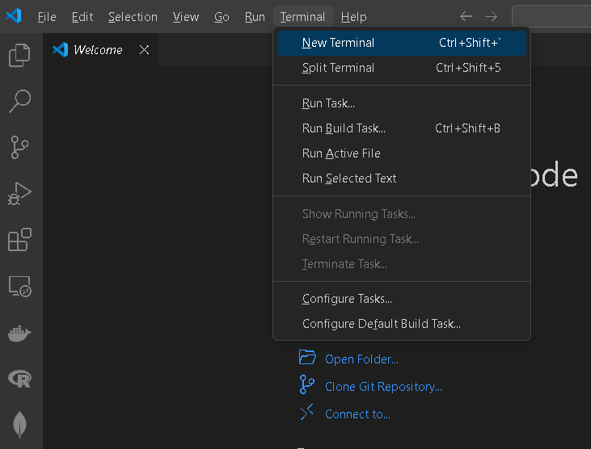

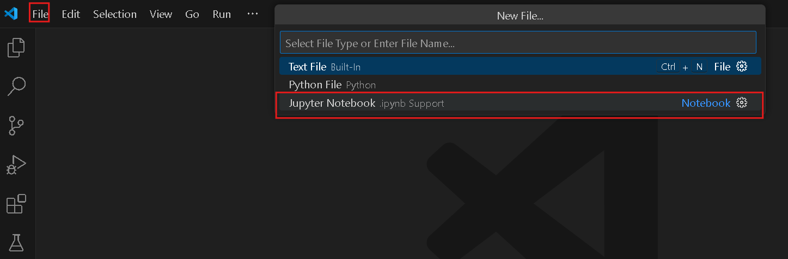

- Inside your “DS522” directory, create a new directory and name it “HOS06A”. Use the following command: >mkdir HOS06A
- Move to the new directory. Use the following command: >cd HOS06A
NOTE: This will be the folder where you store all your HOS06A work.

Data Cleaning and Handling Missing Data
Data cleaning and handling missing data are crucial steps in preparing data for analysis or machine learning. The goal is to ensure that the dataset is accurate, consistent, and ready for further processing. Data cleaning involves identifying and correcting (or removing) errors or inconsistencies in the dataset. The goal is to improve data quality by resolving issues such as:
- Missing or incomplete data
- Incorrect data types
- Duplicates
- Inconsistent formatting
- Outliers
- Noise or irrelevant data

Common Data Cleaning Steps:
- Identifying and Handling Missing Data: Missing data is a common issue in datasets, and it can affect the performance of models or lead to biased results. There are several strategies for handling missing data, which will be discussed in detail below.
- Removing Duplicates: Duplicate data can occur due to repeated entries or merging datasets. Removing duplicates ensures that each observation is unique.
- Correcting Data Types: Data often comes with incorrect data types (e.g., dates stored as strings). Correcting these data types helps ensure that operations and analyses are performed correctly.
- Standardizing Formats: Formatting issues like inconsistent capitalization, date formats, or units can affect analysis. Standardizing the format ensures consistency across the dataset.
- Removing or Imputing Outliers: Outliers can skew analyses and models. Deciding whether to remove or adjust these values depends on the context.
- Handling Inconsistent Data: Sometimes data values may be inconsistent (e.g., 'FL' vs. 'Florida' for the same state). Standardizing these values improves data consistency.

Data cleaning and handling missing data are vital steps to ensure the quality of your dataset. The method you choose depends on the type of data, the amount of missing data, and the specific requirements of your analysis or model. Each technique has its own advantages and limitations, so it is essential to assess the situation carefully before making decisions.

In your HOS06A folder or HOS6A repository, create a New File by clicking File on the top menu bar, then New File, and select the Jupyter Notebook option. Save the file with CTRL + S, rename it to data_cleaning.ipynb

- In Type the following code in a new code and run it to see the output:

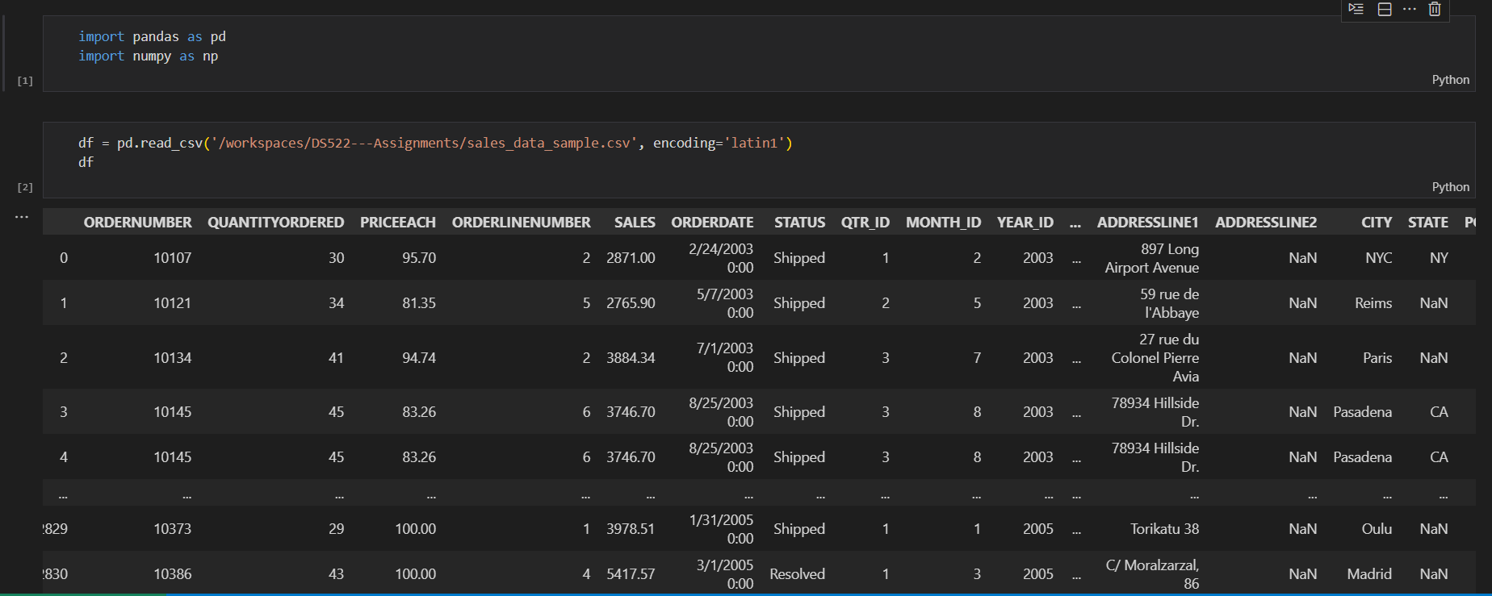

- Before we start cleaning, let us inspect the data for missing values, data types, and basic statistics. Add the following code to your notebook, then run to see the output:

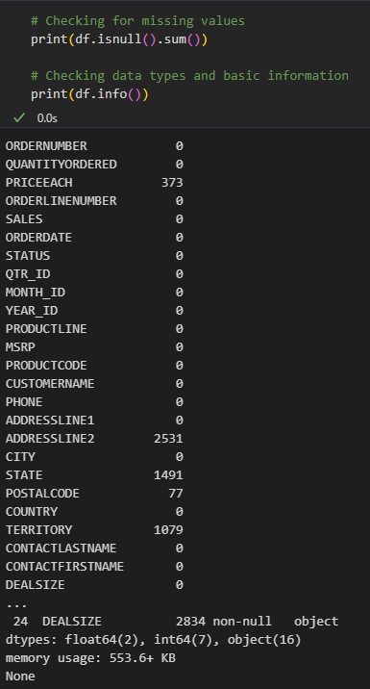

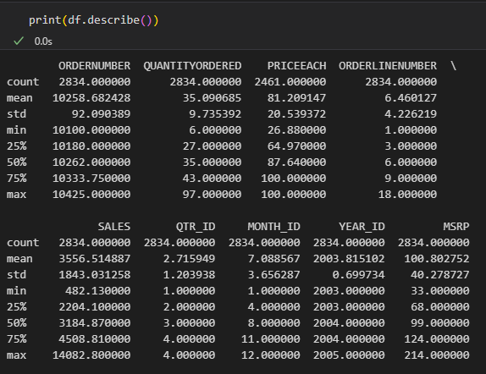

- Handling Missing Data:
  - There are several approaches to handling missing data. First, let us remove N/A or missing values. Type the following codes to perform techniques that are commonly used. Run the code cell and see the output. Take note of the number of rows and columns
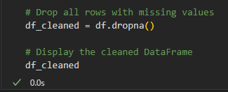

  - Although this approach works, it is not the best way to handle missing data. Instead of deleting all rows or all columns, another option is to remove only the columns that have missing data or are not helpful for the tasks, for example, the ADDRESSLINE2 and TERRITORY columns.
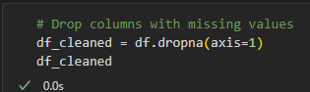

- Then, let us fill in the missing values. Type the following code to fill the missing values with the PRICEEACH column values' mean. Run the code cell and see the output.

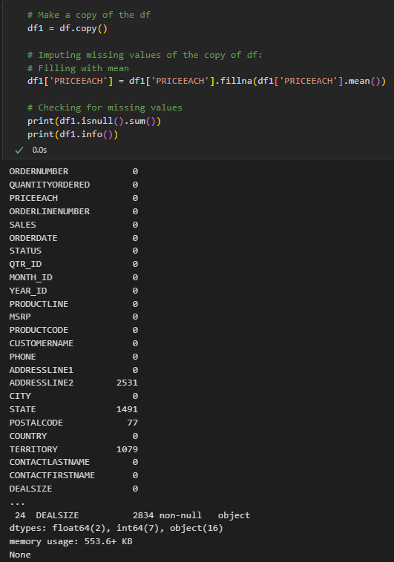
- For categorical data in a column, you can use the column’s mode to fill in missing values. A good example of this is the DEALSIZE column. Let us assume that DEALSIZE has missing values. Type the following code in a new cell and run.

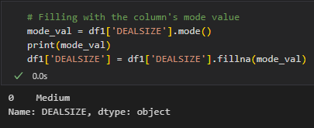

If there were missing row values in the said column, they will be filled with ‘Medium’, which is the most frequently used value in the DEALSIZE column.

- Another approach to filling values is to fill them with either the previous value, using the ffill() method, or the following value, using the bfill() method, of the row with the missing value in the column. Type the code below and run to see the output. Take note of the POSTALCODE column output.

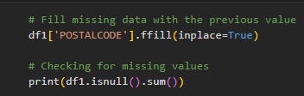

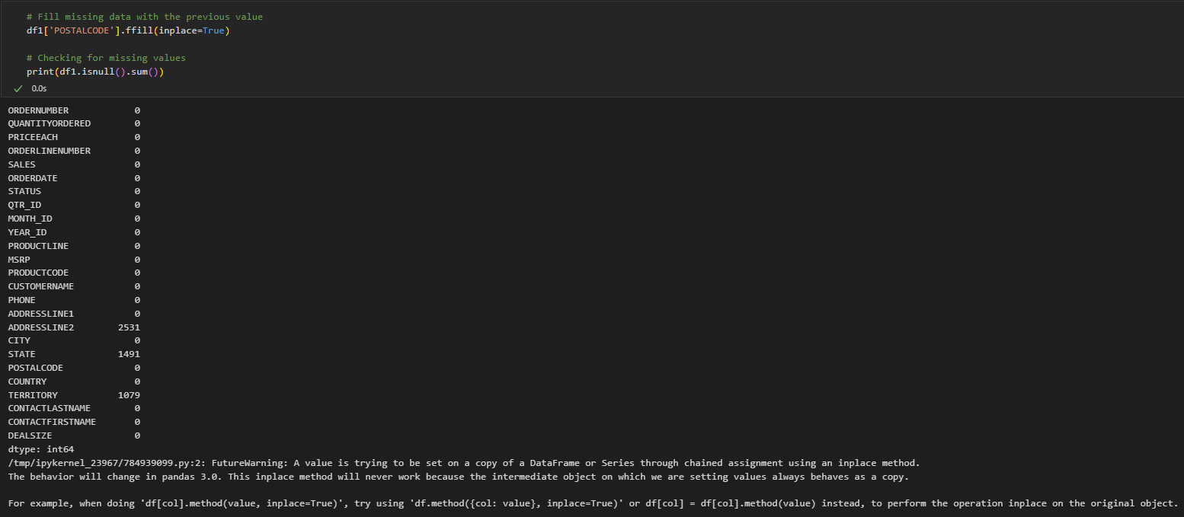

Removing Duplicates:
- duplicated() allows us to spot repeated values. The method returns a Boolean mask indicating whether values in a DataFrame are duplicated. We can use the mask to print the number of duplicate rows and the duplicate rows themselves. Type the following code and run the code cells to see the output:
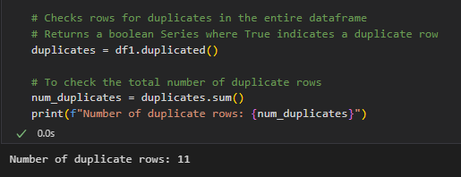

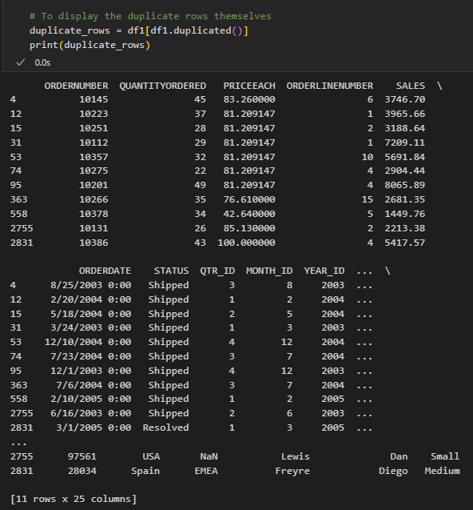
- We can then use drop_duplicates(), which allows us to remove repeated values from a DataFrame. Type the following code in a new code cell and run it to see the output:

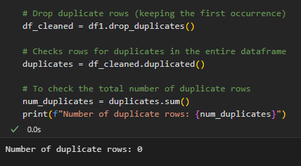

- We can also remove duplicates based on specific columns. Type the code below in a new cell and run to see the output:

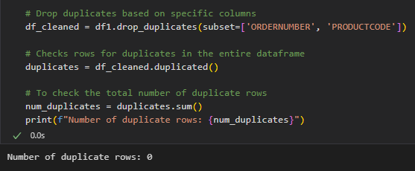

Handling Outliers
We can use proper statistical methods to identify and handle outliers. One way is to compute the interquartile range (IQR) to filter out outliers.

- Let us use the ‘Sales’ column to identify outliers. Type the following code in a new code cell, then run to see the results. Note the number of rows and compare it with the uncleaned data.

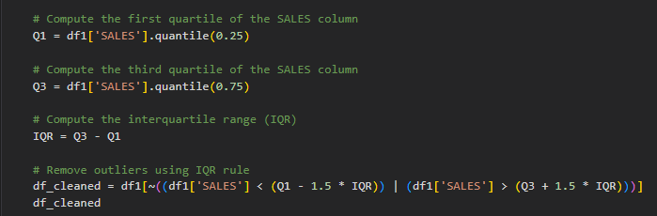

Renaming Columns: Sometimes it is helpful to rename columns for clarity and consistency.

- Let us use the rename () method to rename columns of the dataframe. But first, let us print all the column names. Type the following code in a new code cell, then run it.

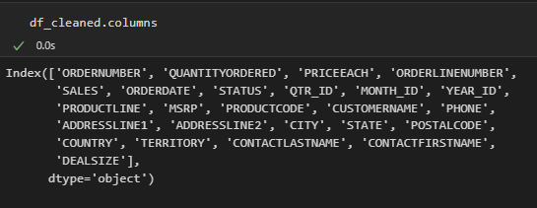

- Now, let us rename the names of the columns that we think are useful. Type the following code in a new code cell, then run it.

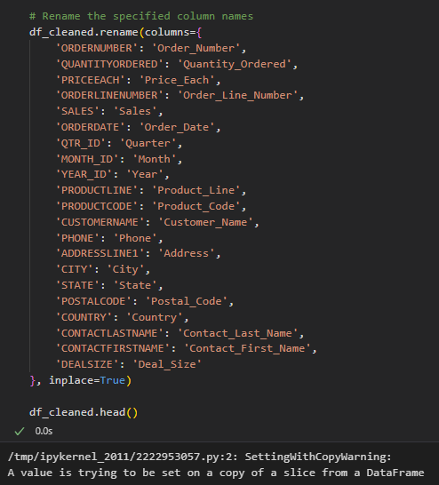

- We can also reprint the column names to see if we have successfully changed them. Compare the output from before and after.

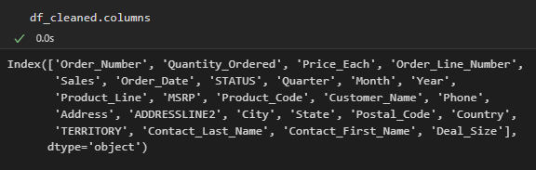

String Manipulation

- First, we will select the columns that we need. Type the following code in a new code cell and run it to see the output:

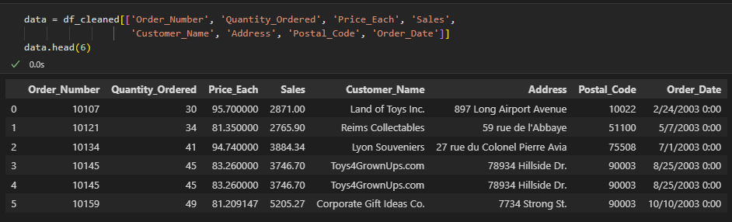

- Next, we will make sure that the Address column is formatted accordingly. Type the following code in a new code cell and run it to see the output:

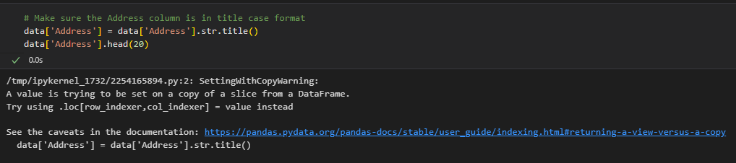

- Let us ensure the consistency of the data in the Address column. First, we are going to check the word ‘Street’ in the Address column. Type the following code in a new code cell and run it to see the output:

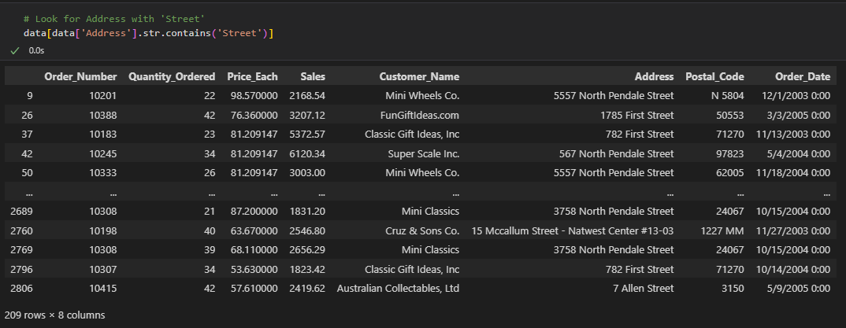

- Now, we are going to change ‘Street’ to ‘St.’ in the Address column. Type the following code in a new code cell and run it to see the output:

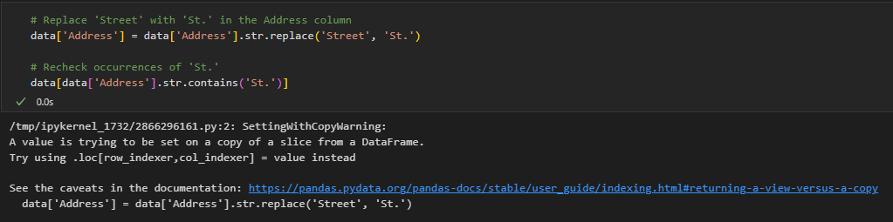

We have covered the basics of the Pandas library, but there is much more that you can do with Pandas. You can learn more here: https://pandas.pydata.org/pandas-docs/stable/user_guide/index.html
*** This is the end of the HOS6A-1 exercise. Please proceed with working on HOS6A-2 and answer HOS06B in Brightspace after pushing your work to GitHub. ***

Push your work to GitHub.
Follow the instructions on the CityU STC TA Center Github.io Submit your work page. You may also follow the instructions below:
- Open the cmd terminal for Windows users,

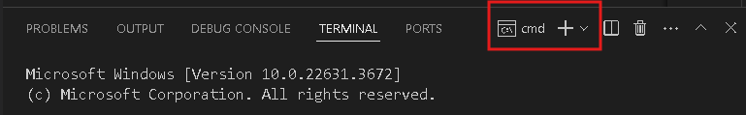

- After selecting the + button, make sure the terminal is cmd if you have not closed the Python terminal. If the terminal is not cmd, you need to add it by opening the drop-down box and selecting the Select Default Profile option.
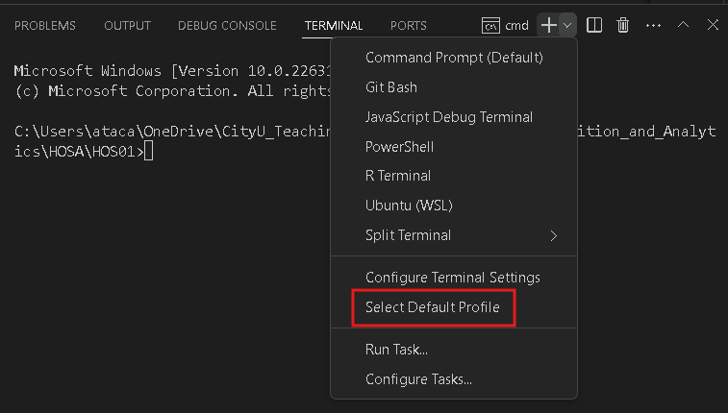

Look for and then select Command Prompt

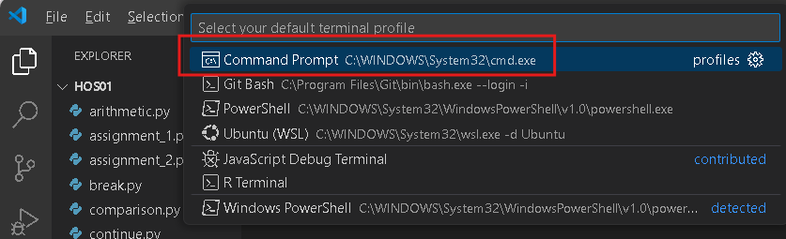

Click the + button. The command prompt will open.

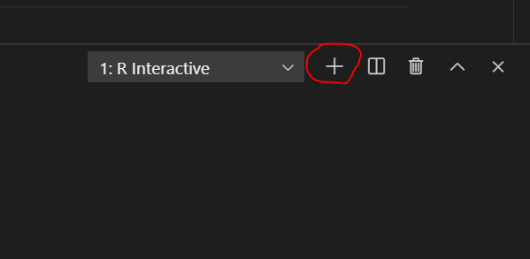

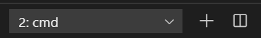

- Make sure you are in the correct directory/repository: Desktop/DS522/hos06a-courseName-yourUserName. Run the following commands to push your work to the GitHub repository.
- Open the terminal from VSCode by hitting the control + ~ key and type the following command:
>>> git add .
>>> git commit -m “Submission for HOS06A-1.”
>>> git push

